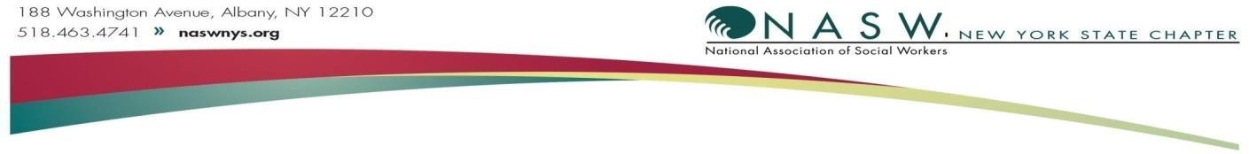

**Memorandum in Support:** Workplace Bullying Prevention Act **(A3482/S1893)**

The National Association of Social Workers is the professional organization for social workers across the country. The New York State and New York City Chapter advocates for the nearly 64,000 licensed social workers in the state and their clients. NASW-NYS/NYC strongly supports Assembly and Senate bill A3482(Bronson)/S1893(Sanders). Passage of this bill would establish a civil cause of action for employees subjected to an abusive work environment.

Studies have shown that “at least one-third of all employees directly experience health endangering workplace bullying, abuse and harassment during their working lives. Such form of mistreatment is four times more prevalent than sexual harassment alone. Workplace bullying, mobbing and harassment can inflict serious harm upon targeted employees, including feelings of shame and humiliation, severe anxiety, depression, suicidal tendencies, impaired immune systems, hypertension, increased risk of cardiovascular disease, and symptoms consistent with posttraumatic stress disorder.”[1] New York’s laws only offer protection from harassment for members of a protected class (as defined by Title VII). “Even if an employer has anti-bullying policies, state and federal laws do not compel employers to follow their own anti-bullying policies; there is no redress if an employer ignores them.”2 It is well past time for all New Yorkers to be protected from workplace harassment and bullying.

The Workplace Bullying Prevention Act creates an opportunity for employees and employers to address workplace bullying and prevent future conflicts. It provides a cause of civil action against the harasser directly, and/or against the employer. In addition, the bill also contains an affirmative defense for the employer from vicarious liability if they “exercise reasonable care to prevent and correct promptly” a bullying situation. Thus, the bill incentivizes prevention and corrective action by the employer, while providing redress for the victim if the harassment continues.

It is imperative that all New Yorkers are legally protected from harassment and workplace bullying. For the above reasons, the NASW-NYS/NYC Chapter supports A3482/S1893.

Signed,

The National Association of Social Workers, New York State Chapter and New York City Chapter

Shakira A. Kennedy, PhD, LMSW

*Executive Director*

P.O. Box 94

Cohoes, NY 12047

Tel: 518-463-4741 ext. 101 Fax: 518-463-6446

skennedy.naswnys@socialworkers.org

1. Workplace Bullying Prevention ActA3482-Bronson/S1893-Sanders. https://www.nysenate.gov/legislation/bills/2025/S1893 2 Paul Siskind, New York Healthy Workplace Advocates.

  