**Memorandum In Support of Reforming Temporary Disability Insurance A84/S172**

The National Association of Social Workers is the professional organization for social workers across the country. The New York State and New York City chapter (NASW-NYS/NYC) is responsible for advocating for the nearly 62,000 licensed social workers in the state as well as their clients. NASW-NYS/NYC strongly supports **A84/S172** which will modernize New York’s paid medical leave system ensuring that all New Yorkers have access to a decent paid leave benefit when they need it. The paid medical leave currently offered in New York has a cap so low that it benefits almost no one, leaving New York workers **one cancer diagnosis, car crash, or difficult pregnancy away from losing their job, health insurance, and financial security.** That is because New York’s paid medical leave benefit (“temporary disability insurance” or “TDI”) provides workers who need time off to care for their own health a mere $170 per week—and no job protection nor guarantee of health insurance. New York’s TDI benefit is wildly inequitable compared both to its peer states (nearly all of which allow workers over $1,000 per week in benefits) and its own paid family leave benefit, which New Yorkers use to care for seriously ill loved ones and to bond with a new child (and through which workers can receive as much as $1,177.32 per week in benefits). In New York, if your father breaks his leg, you can care for him and receive up to $1,177.32 per week and full job protection; if you break your leg and need to be out of work, you will receive only $170 per week and no job protection.

In February of 2023 (updated in January 2025), A Better Balance issued a report with recommendations for the modernization of New York's TDI program–a benefit that has not been touched since 1989–many of which are covered in A84/S172. The report,  [*The Time Is Now: Building the Paid Family and Medical Leave New Yorkers Need*](https://www.abetterbalance.org/the-time-is-now)*,* explains that the TDI system as it currently stands does not support New York’s workers, failing those who are fighting cancer, managing long COVID, substance use disorder, mental health and particularly disadvantaging low wage workers, women, veterans and military families and New Yorkers living with disabilities. Updating TDI with the reforms to job protection, benefit caps, and leave improvements proposed in A84/S172 will create a paid medical leave program that serves all New Yorkers. Strengthening and updating New York’s paid medical leave program will help combat the Black maternal health crisis by ensuring that pregnant New Yorkers can afford to take time off to keep themselves and their pregnancies healthy without risking their economic security.

While New York’s groundbreaking prenatal leave law offers 20 hours of paid leave for pregnant workers, 20 hours is insufficient for those with complicated pregnancies; a comprehensive TDI program will ensure all pregnant workers have the leave they need in order to keep their pregnancies healthy. It will also ensure that those who experience pregnancy loss can take the time they need to recover. It will remedy the absurdity in the current system wherein, for example, someone caring for their partner who has a medical need can receive job-protected leave and decent benefits but if they have the same need they have no job protection for time off taken and are able to receive only $170/week.

A statewide paid medical leave program will also help level the playing field for small businesses in New York. Nearly [***80 percent* of small business owners would like to offer more paid leave than they can currently afford**](https://smallbusinessmajority.org/our-research/workforce/small-businesses-support-national-paid-family-medical-leave-program). Updating New York’s TDI program presents a game-changing opportunity to support businesses, individuals and families.

A84/S172 contains the reforms needed to make these programs work for all New Yorkers. To give New Yorkers the paid medical leave they need, the program must include all the reforms included in A84/S172:

● Remove the $170/week cap on benefits for one’s serious health condition and increase that cap to 67% of the State’s average weekly wage by 2029;

● Provide intermittent leave;

● Protect workers’ jobs and health insurance during medical leave;

These reforms are affordable. Paid family leave is entirely employee-funded, and temporary disability insurance is a shared employer-employee cost; the program's updates can be funded with only a small adjustment to current costs to employers and employees. A84/S172

would transform New York’s paid medical leave program into one on par with modern paid family and medical leave programs across the country. And it would make a profound difference in the lives of New Yorkers, especially those already living paycheck to paycheck. We urge the legislature to pass A84/S172.

For all of the above reasons, the NASW-NYS/NYC Chapter enthusiastically supports **A84/S172**.

Signed,

The National Association of Social Workers, New York State and New York City Chapters

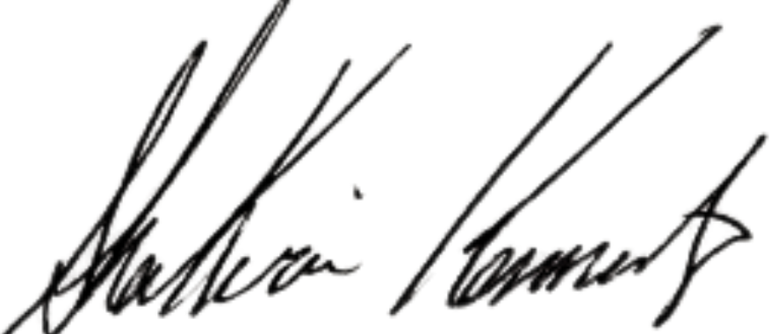

Shakira Kennedy, Ph.D., LCSW

Executive Director

NASW-NYS/NYC

[skennedy.naswnys@socialworkers.org](mailto:skennedy.naswnys@socialworkers.org)

Amanda Pressly

NASW NYS Policy Coordinator

[apressly.naswnys@socialworkers.org](mailto:apressly.naswnys@socialworkers.org)

Ciera Dudley

NASW NYC Policy Coordinator

cdudley.naswnys@socialworkers.org