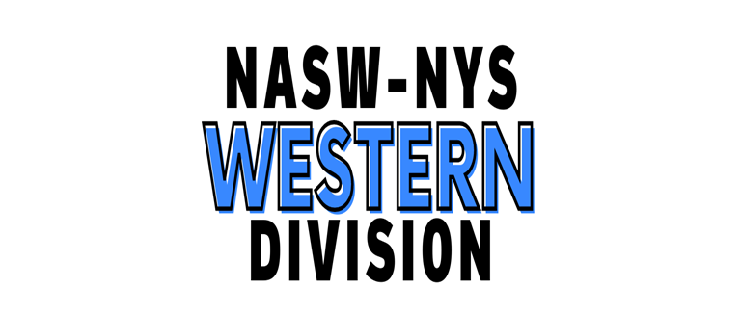
NASW-NYS Western Division Newsletter
Volume two, Issue three, November 2024

Never think that what you have to offer is insignificant.

There will always be someone out there that needs what you have to give. ~Anonymous~

Message from the Division Director
What a glorious fall we have been having so far in Western New York. I hope that you are enjoying it. However, the big news is that Donald Trump will be our next president. I hope that the country can begin to heal from the divisiveness of the recent past now that the election has been decided. May we all work together using our extraordinary social work skills to facilitate this process.
Please consider sending me your bio for the upcoming editions of the newsletter to introduce yourself to all of our wonderful members.
As always, please let us know what’s on your mind regarding the Division and how we can work together to meet your needs. You can always reach me at
nasw-nyswestern@gmail.com
Thanks for all you do,
Elaine

WELCOME TO ALL OUR NEW MEMBERS!!
WE ARE SO HAPPY THAT YOU HAVE JOINED OUR PROFESSIONAL ORGANIGATION AND LOOK FORWARD TO YOUR PARTICIPATION IN THE WESTERN DIVISION.

Virtual CEU events-presented
September 6, 2024 – 12-3 pm Dr. Berg Miller, Buffalo State University, Department of Social Work, Putting Intersectionality into Practice to Serve Multiply Marginalized Groups
Upcoming-Virtual
Date and time TBD, by Ms. Kerry Causey, LCSW, Trauma-Informed Supervision: Practical Strategies for Workforce Resiliency
Date and time TBD by Mr. James Coco, LCSW, Mitigation specialist for the federal defender of the Southern District Indianapolis, Indiana, doctoral candidate, The intersection of forensic and mental health social work practice.

November 9, 2024 – 9-10:30 am by Dr. Mark Frank, University at Buffalo, Professor, Department of Communication & Director, Communication Science Center, Deception and Detection: Skills and Strategies to Read Behavior and Elicit Truthful Information.
BSW/MSW Program
An invitation was sent to program heads asking them to forward a request to the president of their schools Phi Alpha Honor Society chapter. I have asked that the chapter make a short video for us to share with students on why they should consider joining NASW. So far, I have only heard from the president of the Fredonia University chapter. She was very enthusiastic about doing this and will bring the idea back to her members for consideration.

We will be visiting, either in person or virtually, Buffalo State University, Fredonia University, and Daemen University as the academic year progresses.
Meet the Members
Please send me your bios to share!!

A Recent Tragic Loss of a social worker and her children in WNY

Some of you may be aware of the recent deaths of a local social worker and her two children who jumped into the Niagara River near the Falls. I have provided the link to this tragic story and a message to the family from all of our WNY members that will be sent to them via the Chapter office.

https://www.wgrz.com/article/news/local/vigil-niagara-falls-deaths-mother-children/71-cb10b6f5-40b6-42f7-b9b1-14379a9c24f6

To the family of Chaianti, Roman, and Mecca,

There are no words to express how deeply sorry we are for your loss of Chaianti, Roman, and Mecca. We cannot begin to imagine what you are feeling at this time.
Please know that all of our Western Division members of the National Association of Social Workers, New York Chapter, send you our deepest sympathy as you negotiate this tragic time in your lives.
May you all find some relief from your pain knowing that others care about you.

Schedule of upcoming division meetings.
These are all virtual. Just go to the NASW-NYS website to register and you will be able to log in to the meeting. Hope to see you at any of these meetings that you are able to attend. Here is the link https://naswnys.org/
Western Division Meeting Calendar for 2024-2025
 | Steering Committee  First Tuesday of the Month  6-7:30 PM | Clinical Meeting  Third Monday of the Month  6-7:30 PM
July 2024 | 7/2/2024 | No meeting
August | 8/6 | No meeting
September | 9/3 | 9/16/2024
October | 10/1 | 10/21
November | 11/5 CNC | Steering Committee Mtg & Clinical Mtg 11/18
December | 12/3 | 12/16
January 2025 | 1/7/2025 | 1/20/2025
February | 2/4 | 2/17
March | 3/4 | 3/17
April | 4/1 | 4/21
May | 5/6 | 5/19
June | 6/3 | 6/16

Sincerely,
Elaine Rinfrette, PhD, LCSW-R, NASW-NYS Western Division Director

Steering Committee Members: Sylvia Gold, LCSW-R, Cheryl Eberl, LCSW-R, Cheryl Mills, LCSW-R, Jesse Grossman, LCSW-R, BCDCSW

