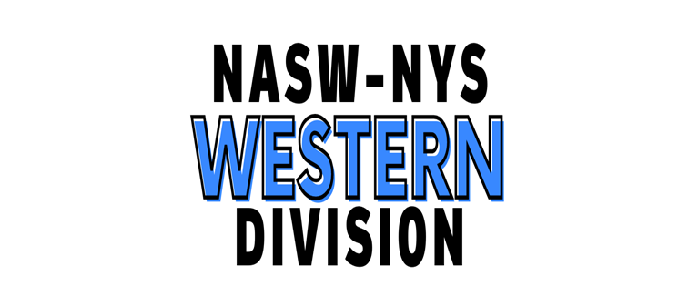
NASW-NYS Western Division Newsletter
Volume one, Issue four, May 2024

Never think that what you have to offer is insignificant.

There will always be someone out there that needs what you have to give. ~Anonymous~

Message from the Division Director
Welcome to spring! It’s a lovely time in WNY that leads to a great summer.
We’ve been busy the past two months with preparing for graduations, giving Student of the Year awards, planning events that we hope you will enjoy and find useful, and greeting new members.
As always, please let us know what’s on your mind regarding the Division and how we can work together to meet your needs. You can always reach me at nasw-nyswestern@gmail.com
Thanks for all you do,
Elaine

WELCOME TO ALL OUR NEW MEMBERS!!
WE ARE SO HAPPY THAT YOU HAVE JOINED OUR PROFESSIONAL ORGANIGATION AND LOOK FORWARD TO YOUR PARTICIPATION IN THE WESTERN DIVISION.

Student of the Year awards by Western division
Fredonia –Bethany Anderson, BSW
Niagara – Nathan Eitler, BSW
UB –Aditi Kumar, MSW
Daemen –Tatiana Nowakowski, BASW, Macie Clawson, MSW
Buffalo State – Rachel Marillo, BSW
All awardees receive a certificate in a holder, t-shirt, pen, membership postcard, and key chain.
All graduates get key chains and membership postcard on how to join NASW (total=367)
Blurb to schools for their graduation/commencement program:
The Western Division of the National Association of Social Workers (NASW)-New York State Chapter established this award to be given to a student who has demonstrated academic excellence and personifies the values of the Social Work profession as defined by the NASW Professional Code of Ethics.
We are pleased to present this award to XXXXXXXXXXX who exemplifies these qualities!
Welcome to the fabulous profession of social work that you are about to enter.
You will be rewarded many times over during your career by the work you do to help clients, by the chance to learn about yourself, by pursuing life-long learning opportunities, and by the relationships you develop with others.
We encourage you to join NASW, your professional organization, and look forward to your participation in the Western Division!
Congratulations!
Virtual CEU event-presented
April 11, 2024, 9-10:30 am, Mandy Fauble, PhD, Suicide Prevention: What’s Working? #58
Very well received!!
Upcoming In-person
May 17, 2024, 1-2:30 pm, Emma Fabian, MSW, Evergreen Health Services-Associate Vice President of Harm Reduction, Overdose Prevention and Naloxone Administration, Explore Buffalo Office at First Presbyterian Church, 1 Symphony Circle, Buffalo. REGISTER NOW TO MAKE SURE THIS TRAINING OCCURS. LAST DATE TO REGISTER IS MAY 7TH.
Upcoming-Virtual
May 9, 2024 – 9-10:30 am by Dr. Braden Linn, Pennsylvania State University School of Medicine, Advances in Treatment Research for Alcohol Use Disorder
June 13, 2024 – 9-10:30 am by Dr. Steven Haladay, Edinboro University, Department of Social Work, Is social work ethical?
July 15, 2024 – 2-5pm Dr. Berg Miller, Buffalo State University, Department of Social Work, Putting Intersectionality into Practice to Serve Multiply Marginalized Groups
October 10, 2024, 9-10:30 am by Ms. Kerry Causey, LCSW, University of Denver, School of Social Work, Trauma-Informed Supervision: Practical Strategies for Workforce Resiliency
October 17, 2024, 2:30-4:30 pm by Mr. James Coco, LCSW, mitigation specialist for the federal defender of the Southern District Indianapolis, Indiana, The intersection of forensic and mental health social work practice.

November 9, 2024 – 9-10:30 am by Dr. Mark Frank, University at Buffalo, Professor, Department of Communication & Director, Communication Science Center, Deception and Detection: Skills and Strategies to Read Behavior and Elicit Truthful Information.
Annual meeting: June 10th, 6-8pm, Parker Hall, Room 214
Park behind Parker in the lot off Winspear, take elevator to 2nd floor.
Come join us for an evaluation and planning meeting and a casual dinner. RSVP at https://docs.google.com/forms/d/e/1FAIpQLSf_u9UxqVclT85aB7px0IVfkdIrgqWBiyd8g_OQXU0GqLLqpw/viewform?usp=sf_link
Raffle May 1 drawing, winners notified by email
Spring breakfast – Monday May 6, 10-11 am at Dash’s Market, 1770 Hertel Ave, 2nd floor, Buffalo, elevator available.
Come and have a bite on us and meet members of the Steering Committee
Possible Upcoming Chapter Chats – Parachute financial planning organization, Special Interest Group (SIG) with Elaine and Cecily Mitchell, LMSW to determine interest for mentoring of professional development for new graduates.
Connection with PAWNY – Psychological Association of WNY made
This connection was re-established with a great welcome. We look forward to working together on trainings and other events.
MSW student from UB possible – approved by the Executive Director!
Summer plans – picnic with VAMC?, other ideas? Let us know!!
Sincerely,
Elaine Rinfrette, PhD, LCSW-R, NASW-NYS Western Division Director

Steering Committee Members: Sylvia Gold, LCSW-R, Cheryl Eberl, LCSW-R, Cheryl Mills, LCSW-R, Jesse Grossman, LCSW-R, BCDCSW

