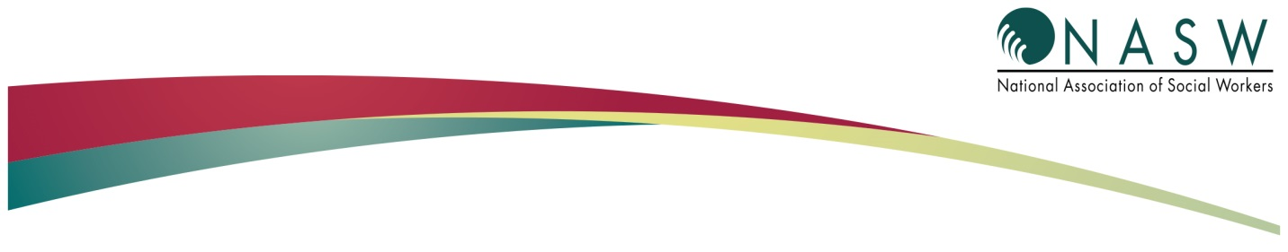
PRACTICE ALERT

Highlights of the Medicare CY 2021
Physician Final Rule
December 2020

On December 1, 2020, the Centers for Medicare and Medicaid Services (CMS) released the final rule for the Medicare Physician Fee Schedule.

The rule is effective January 1, 2021 and applies to Medicare providers including clinical social workers (CSWs).

The following is a summary of the rule provisions that apply to CSWs.

Reimbursement

There are both increases and decreases in reimbursement rates for the psychotherapy codes that CSWs bill. They are outlined in the table below and reflect nationwide rates. The decreases were made to offset increases in payment for office and outpatient evaluation and management (E/M) services. These offsets are required in order to achieve Medicare budget neutrality. They are impacting many provider types in the Medicare program in addition to CSWs.

Despite NASW’s efforts, together with scores of other provider groups, to work with Congress to waive the budget neutrality requirement that forced the offset, CMS will reduce the conversion factor (CF) —a multiplier used to determine practitioners’ Medicare payments — by 10.2%. Under Medicare’s payment formula, each billing code’s values for work, practice expense, and malpractice expense are multiplied by the CF, along with a geographic index, and combined to create the payment amount.

NASW continues to advocate vigorously to engage Congress to stop these harmful cuts!

CPT Code | Code Descriptor | % Change (RVU Payment Rate)
90785 | Interactive Complexity | -10.2%
90791 | Psychiatric diagnostic evaluation | 15.7%
90832 | Psychotherapy, 30 minutes with patient | 3.0%
90834 | Psychotherapy, 45 minutes with patient | 1.5%
90837 | Psychotherapy, 60 minutes with patient | -0.1%
90839 | Psychotherapy for crisis; first 60 minutes | -8.7%
90840 | Psychotherapy for crisis; each additional 30 mins | -8.4%
90845 | Psychoanalysis | -9.2%
90846 | Family psychotherapy (without the patient present), 50 minutes | -11.1%
90847 | Family psychotherapy (conjoint psychotherapy) (with patient present), 50 minutes | -11.1%
90849 | Multiple-family group psychotherapy | -10.2%
90853 | Group psychotherapy | -9.0%
90863 | Pharmacologic management | -11.4%

Telehealth

- Group Psychotherapy, 90853, has been added to the permanent (category 1) list of telehealth psychiatric services.

- The restriction on the use of telephones for telehealth services has been removed. Telephones, such as smartphones, that fit the definition of “multimedia communications equipment that includes audio and video equipment permitting two-way, real-time interactive communication” may be used for Medicare telehealth services. These can be used in addition to the previously permissible communication methods such as video conferencing.

- The use of audio-only telephones for telehealth services will not be eligible for payment after the expiration of the public health emergency (PHE) on January 20, 2021. CMS believes that it does not have the authority extend the current flexibility allowing the use of audio-only devices. The administration may extend the PHE and congressional lawmakers are working to waive this restriction. NASW continues to advocate for permanent audio-only telehealth.

- The geographic and originating site restrictions that were lifted during the PHE (which enabled clients to, for example, receive telehealth services from their home) were not extended beyond the expiration of the PHE. The site flexibilities will conclude on January 20, 2021 at the end of the PHE unless the PHE is extended or this restriction is removed permanently. NASW continues to advocate for the removal of geographic and originating site restrictions.

- CSWs may furnish brief online assessment and management services, remote evaluation services, and virtual check-in services. This is a permanent policy change. To identify these services, CSWs may use HCPCS codes G2061- 5 to 10 minutes, G2062 – 11 to 20 minutes, and G2063 – 21 minutes or more. These services must be performed through a digital platform such as a patient portal. HCPCS code G2261 is used for telephone assessments and is used for 5-10 minutes.

- Subsequent nursing facility visits are now limited to one Medicare telehealth visit every 14 days, instead of once every three (3) days.

- The in-person requirement in the Medicare Diabetes Prevention Program (MDPP) has been eliminated. During the PHE, all MDPP services can be delivered virtually.

- MDPP suppliers may accept self-reported MDPP beneficiary weight measurements via a photograph of the beneficiary’s digital scale.

Practice Expense for Personal Protective Equipment

Supply pricing increases for surgical masks and face shields that are bundled into some office-based procedure codes are being implemented on an interim rule basis. CMS is seeking comments on this interim final policy on how to account for services that do not include these specific PPE items but for which there are increased costs which may include psychiatric services.

Substance Use Disorder Treatment

Naloxone has been added to the definition of Opioid Use Disorder (OUD) treatment services in order to increase access to emergency treatment. Opioid Treatment Programs (OTPs) will be paid for dispensing naloxone to patients receiving OUD treatment services. Patients being treated at OTPs may receive take-home supplies of nasal naloxone on an as-needed basis from their OTP with no cost sharing.

Payment for patient education about overdose and use of naloxone will be added to the payment for the medication instead of through a separate education code.

Medicare Record Documentation

Medical students and students of other disciplines working under a physician or practitioner who furnishes and bills directly for Medicare services, may document in the record as long as the document is reviewed, signed, and dated by the billing practitioner.

Quality Payment Program

CSWs were not added as an eligible provider in Medicare’s Quality Payment Program for 2021. However, the final rule does provide a list of measures appropriate for use by CSWs.

