CONTINUING EDUCATION COURSE PROPOSAL
NATIONAL ASSOCIATION OF SOCIAL WORKERS – NEW YORK STATE CHAPTER (NASW-NYS)

Program Name:

Date/Time:

Location:

Continuing Education
Contact Hours: Note: One (1) Continuing Education Hour = 50 Minutes

Presentation Type: On-Line

Teaching Methods: Lecture Multimedia Experiential Activities
(Check all that apply)

Technology Questions:
Have you ever presented a webinar before? Yes No Not sure
Have you previously used online platoforms to virtually connect (Ex: GoToWebiar, Zoom, etc.)? Yes No Not sure
Does your computer have a built in microphone for audio? Yes No Not sure

Practice Areas: (Check all that apply)
Addictions | Administration/Management/Leadership
Advocacy | Aging
Child Welfare | Children and Youth
Clinical | Community Organizing
Community Development/Planning | Criminal Justice/Courts/Forensics
Disabilities | Displaced Persons (i.e., Homeless, Refugees)
Diversity | Families
Ethics | Health
International Social Work | Mental Health
Military/Veterans | Occupational Social Work
Philanthropy | Policy
Poverty/Income | Private Practice
Public Health | School Social Work
Social Work Education | Supervision
Trauma/Violence | Other: _______________________________

Age Groups: Children Adolescents Adults Older Adults N/A
(Check all that apply)

Audience: Student Emerging (Beginner)
(Check all that apply) Mid-Career (Intermediate) Advanced (Expert)

NEW YORK STATE EDUCATION DEPARTMENT (NYSED) IDENTIFIED TOPICS

The Continuing Education Course must contribute to the professional practice of social work and have at least one of the NYSED topics identified below as its focus. Please check all that apply.

Theories and concepts of human behavior in the social environment
Social work practice, knowledge, and skills
Social work research, programs, or practice evaluations
Social work management, administration or social policy
Social work ethics
Clinical interventions, evidence-based models, and principles of clinical social work practice, psychotherapy, and clinical social work diagnosis
Client communications and recordkeeping
Administrative supervision of licensed master social work and clinical supervision of licensed clinical social work practice
Pedagogical methodologies or other topics that contribute to the professional practice of licensed master social work and licensed clinical social work.

COURSE DESCRIPTION
Please provide a brief description (5-10 sentences) of the continuing education course content. It should reflect a draft outline of the course.

Type or Copy Paste Here:

LEARNING OBJECTIVES
Please provide 3-5 learning objectives describing what participants should be able to do upon completion of the continuing education course (i.e., apply new knowledge, skills, abilities). Please see information on how to write learning objectives available at https://tips.uark.edu/using-blooms-taxonomy/

Following this course, participants will be able to:

Timed Agenda
Please outline the presentation topics and the approximate time for each topic. Please be aware that approximately 15 minutes should be available for participant Q&A and discussion. NASW-NYS will assign CE credit hours for every 50 minutes of presentation.

Post Test Questions
Please submit 10 multiple choice post test questions, with answer key for the attendees to receive continuing education credits for this course. Once the course has been approved, you will be required to provide copies of any handouts and PowerPoints. The questions and answers should reflect that the participant has mastered the learning objectives and presented material.

INSTRUCTOR INFORMATION

Instructor(s):

Credentials:

Mailing Address:

Primary Email:

Primary Phone:

Instructors are asked to provide a short bio (3-5 sentences) documenting their education, work experience or background, and specific expertise related to the subject matter or topic. They are also asked to provide a recent photo for use in marketing efforts.

Type or Copy Paste Here:

In addition, instructors should provide a copy of their current resume or curriculum vitae to demonstrate their ability to provide the proposed continuing education training. The resume or curriculum vitae should specific highlight previous trainings provided on related topics. The bio will be used to market the continuing education course while the resume or curriculum vitae will serve as documentation for NYSED.

Finally, presenters should provide a copy of their reference list and/or any resource materials they plan to use in the development of the course. All references/resources should be recent, within the past 10 years unless seminal or historical in nature. Please provide an explanation for any reference materials that are seminal or historical in nature and note that these will require prior approval by our CE department.

COURSE LOCATION
Using the map below, please let us know to which NASW-NYS Divisions you are willing to travel.

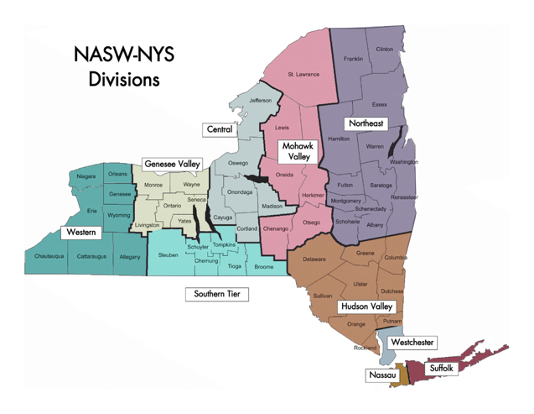
Materials Checklist (confirm all supplied):
Please review and Mark when completed | Completed/Submitted
Application
NYSED Identified Topics
Course Description
Learning Objectives
Post-Test Questions
Presenter Bio
Presenter Photo
Reference/Resource List
Résumé/Curriculum Vitae
Course Location

