CONTINUING EDUCATION COURSE PROPOSAL
NATIONAL ASSOCIATION OF SOCIAL WORKERS – NEW YORK STATE CHAPTER (NASW-NYS)

Program Name:______________________________________________________________

Date/Time:_________________________________________________________________

Location: __________________________________________________________________

Continuing Education
Contact Hours: ________ Note: One (1) Continuing Education Hour = 50 Minutes

Presentation Type: In-Person On-Line Hybrid Self-Study

Teaching Methods: Lecture Multimedia Experiential Activities
(Check all that apply)

Practice Areas: (Check all that apply)

Addictions | Administration/Management/Leadership
Advocacy | Aging
Child Welfare | Children and Youth
Clinical | Community Organizing
Community Development/Planning | Criminal Justice/Courts/Forensics
Disabilities | Displaced Persons (i.e., Homeless, Refugees)
Diversity | Families
Ethics | Health
International Social Work | Mental Health
Military/Veterans | Occupational Social Work
Philanthropy | Policy
Poverty/Income | Private Practice
Public Health | School Social Work
Social Work Education | Supervision
Trauma/Violence | Other: _______________________________

Age Groups: Children Adolescents Adults Older Adults N/A
(Check all that apply)

Audience: Student Emerging (Beginner)
(Check all that apply) Mid-Career (Intermediate) Advanced (Expert)

NEW YORK STATE EDUCATION DEPARTMENT (NYSED) IDENTIFIED TOPICS

The Continuing Education Course must contribute to the professional practice of social work and have at least one of the NYSED topics identified below as its focus. Please check all that apply.

Theories and concepts of human behavior in the social environment
Social work practice, knowledge, and skills
Social work research, programs, or practice evaluations
Social work management, administration or social policy
Social work ethics
Clinical interventions, evidence-based models, and principles of clinical social work practice, psychotherapy, and clinical social work diagnosis
Client communications and recordkeeping
Administrative supervision of licensed master social work and clinical supervision of licensed clinical social work practice
Pedagogical methodologies or other topics that contribute to the professional practice of licensed master social work and licensed clinical social work.

COURSE DESCRIPTION
Please provide a brief description (3-5 sentences) of the continuing education course content. It should reflect a draft outline of the course.

______________________________________________________________________________________________________________________________________________________________________________________________________________________________________________________________________________________________________________________________________________________________________________________________________
__________________________________________________________________________________________________________________________________________________________________________________________________________________________________________
__________________________________________________________________________________________________________________________________________________________________________________________________________________________________________
LEARNING OBJECTIVES

Please provide 3-5 learning objectives describing what participants should be able to do upon completion of the continuing education course (i.e., apply new knowledge, skills, abilities). Please see information on how to write learning objectives available at https://tips.uark.edu/using-blooms-taxonomy/

Following this course, participants will be able to:

- ______________________________________________________________________________
- ______________________________________________________________________________
- ______________________________________________________________________________
- ______________________________________________________________________________
- ______________________________________________________________________________

Timed Agenda
Please outline the actual presentation topics, approximate time for each topic and number of CEs allocated per each timeframe. Please be aware that approximately 15 minutes should be available for participant Q&A and discussion.

Post Test Questions
*If this is a live webinar only, we will need one post question per learning objective from the presenter. Please attach separately.
*If the course is going to be utilized as a self-study, please submit a separate 10 question multiple choice post-test with answer key for the first hour and an additional 5 multiple choice questions for each additional hour or half hour. You can include up to two true/false questions. Multiple choice questions must include 4 answer choices (none/all of the above questions are not permitted.) Once the course has been approved, you will be required to provide copies of any handouts and PowerPoints.

INSTRUCTOR INFORMATION

Instructor(s):______________________________________________________________

Credentials:_______________________________________________________________

Mailing Address:___________________________________________________________

Primary Email: _____________________________________________________________

Primary Phone: ____________________________________________________________

Social Media Contacts: (can be written here or emailed to CE Coordinator): ____________
_______________________________________________________________

Instructors are asked to provide a short bio (3-5 sentences) documenting their education, work experience or background, and specific expertise related to the subject matter or topic. They are also asked to provide a recent photo for use in marketing efforts.
______________________________________________________________________________________________________________________________________________________________________________________________________________________________________________________________________________________________________________________________________________________________________________________________________________________________________________________________________________________________________________________________________________________________________________________________________________________________________________________________________________________________________________________________

In addition, instructors should provide a copy of their current resume or curriculum vitae to demonstrate their ability to provide the proposed continuing education training. The resume or curriculum vitae should specific highlight previous trainings provided on related topics. The bio will be used to market the continuing education course while the resume or curriculum vitae will serve as documentation for NYSED.

Finally, presenters should provide a copy of their reference list and/or any resource materials they plan to use in the development of the course. All references/resources should be recent, within the past 10 years unless seminal or historical in nature. Please provide an explanation for any reference materials that are seminal or historical in nature and note that these will require prior approval by our CE department.

COURSE LOCATION

Using the map below, please let us know to which NASW-NYS Divisions you are willing to travel.

______________________________________________________________________________

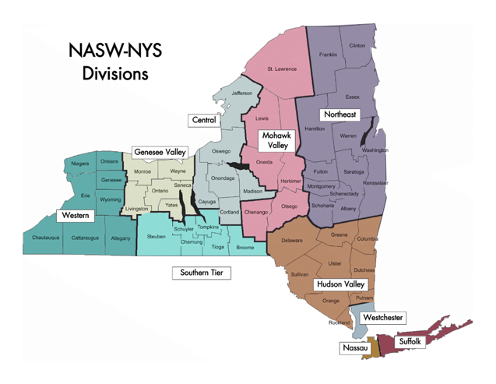
Materials Checklist (confirm all supplied):
Please review and Mark when completed | Completed/Submitted
Application
NYSED Identified Topics
Course Description
Learning Objectives
Post-Test Questions
Presenter Bio
Presenter Photo
Reference/Resource List
Résumé/Curriculum Vitae
Course Location

